ECE 313 Lecture Notes
Lecture 5 on Sampling & Aliasing Part 3
Tuesday, September 22, 2026
By TA Alice Liu

Demonstration of audio effects
- Tremolo. The Smiths, "How Soon is Now?", opening guitar riff has a tremolo effect by guitarist Johnny Marr, with a second voice playing slide guitar. Tremolo is rapid change in volume to give a sensation of motion, and is rapidly varying amplitude modulation effect. "Songs that Changed Music: The Smiths - How Soon Is Now".
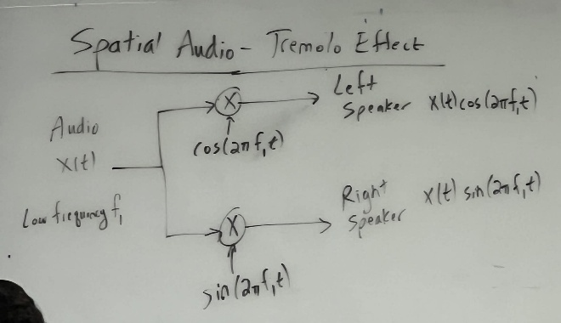
- Another Tremolo Effect: Spatial Audio.
Play an audio signal that ping-pongs between the left and right audio channels (speakers) using amplitude modulation. When cosine is 1, the sine is zero, and vice-versa. The cosine and sine signals have low frequencies such as 1 Hz or 5 Hz.
- Vibrato. Chris Isaak, "Wicked Games", an example of vibrato effort using a guitar whammy bar. Vibrato is a slowly varying frequency modulation effect.
- Delay. Stella, Reverb and Delay Explained, start at 1:11 mark. Delay controls when echoes arrive, whereas reverb consists of delays that are not controlled.
…
Logistics:
- Mini-Project #1 Due Wednesday by 11:59pm on the course Canvas page
- Homework #3 to be assigned, due Friday by 11:59pm
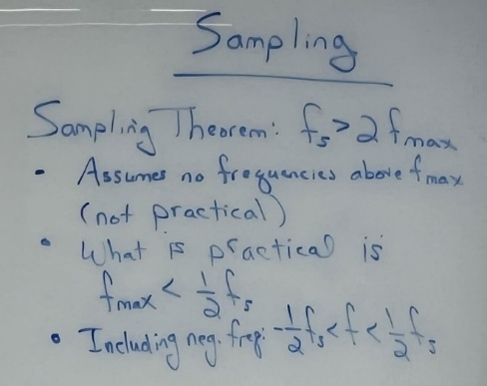
…
Review of Sampling
The Sampling Theorem says that if a continuous-time signal x(t) has no frequencies higher than f_{max}, then the signal can be reconstructed from its samples if the sampling rate c is chosen to be f_{s} > 2 f_{max}. This is a wonderful theoretical result upon which practice builds on. When sampling at sampling rate f_{s}, frequencies up to but not including ½ f_{s} are captured.
Sampling and Reconstruction
- Continuous Time discussion
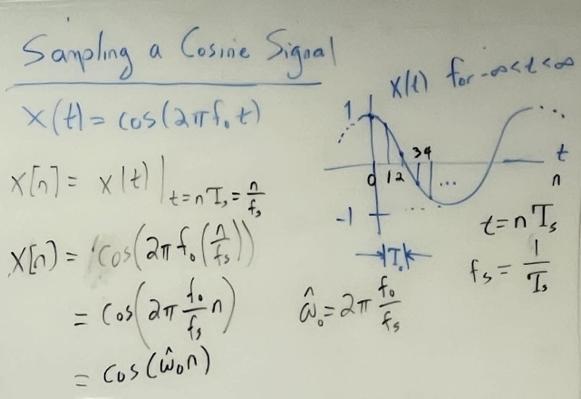
  - To properly recreate the signal (all its frequency components), sampling frequency, $f_{s}$, must satisfy: $f_{s}$ > 2*$f_{max}$, where fmax is the highest frequency component in the signal
  - Alternatively: given a sampling frequency, $f_{max}$, we can reconstruct any signal where its highest frequency component satisfies: $f_{max}<\frac{1}{2}f_{s}$
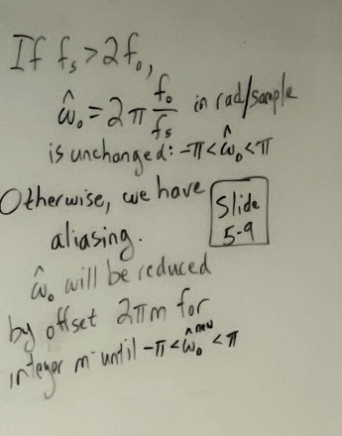
  - Otherwise, we will have aliasing
- Discrete Time discussion
  - Given a continuous time sampling frequency, $f_{s}$, in cycles per second, and a continuous time signal with a maximum frequency component, $f_{0}$, in cycles per second, the discrete time sampling frequency, $\hat{w_{0}}$, that satisfies the Sampling Theorem should be: $\hat{w_{0}}=2π\frac{f_{0}}{f_{s}}$, in radians per sample, where $-π≤\hat{w_{0}}≤π$
  - Else, if the Sampling Theorem does NOT hold, then ALIASING occurs, and $\hat{w_{0}}$ must be adjusted!
- Aliasing Example (see Slides 5-9)
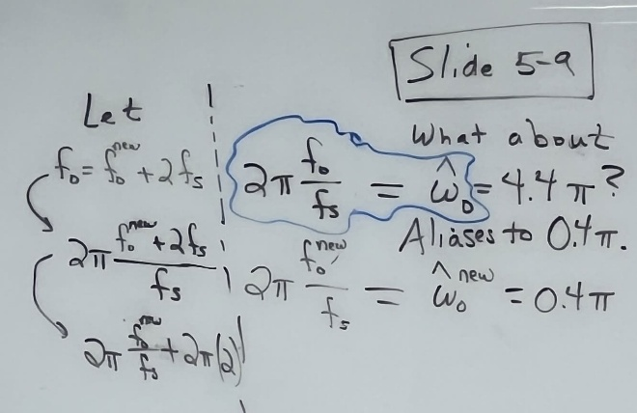
Aliasing
- Classic “Aliasing”
  - Cause: Sampling rate f_{s} does not satisfy the Sampling Theorem
  - Results: After sampling, consider a frequency f₀ that was captured correctly by sampling because f_{s} > 2 f_{0.} However, there are also an infinite number of frequencies outside the range -½ f_{s} < f < ½ f_{s} that will alias to frequency f₀ due to sampling. These aliasing frequencies are of the form f₀ + m f_{s} where m is an integer.
- Another kind of aliasing: Folding
  - Cause: Sampling rate f_{s} does not satisfy the Sampling Theorem
  - Results: After sampling, consider a frequency f₀ that was captured correctly by sampling because f_{s} > 2 f_{0.} However, there are also an infinite number of frequencies outside the range -½ f_{s} < f < ½ f_{s} that will alias to frequency f₀ due to sampling. These aliasing frequencies are of the form -f₀ + m f_{s} where m is an integer.
Reconstruction
- Ideal Reconstruction
  - Sampling satisfies Sampling Theorem
  - Not realistic
    - We can’t sample every possible point
  - Not practical
    - We don’t need every possible point, we can work off of fewer samples
      - Saves space, compute
- Interpolation between sampled points
  - Zero-order Hold
    - Pro: Simple implementation
    - Con: clear artifacts
    - Application: used in some designs for digital-to-analog converters
  - Linear
    - Pro: Pretty good approximation
    - Con: more work, still has artifacts
    - Application: used in speech and audio signals; causes blurring effects in images
  - Curve-fitting
    - Pro: smooth curve
    - Con: complex implementation
    - Application: commonly used when expanding an image and interpolating the pixel values for the new pixels (e.g. expanding a 512 x 512 image into a 2048 x 2048 iimage).

